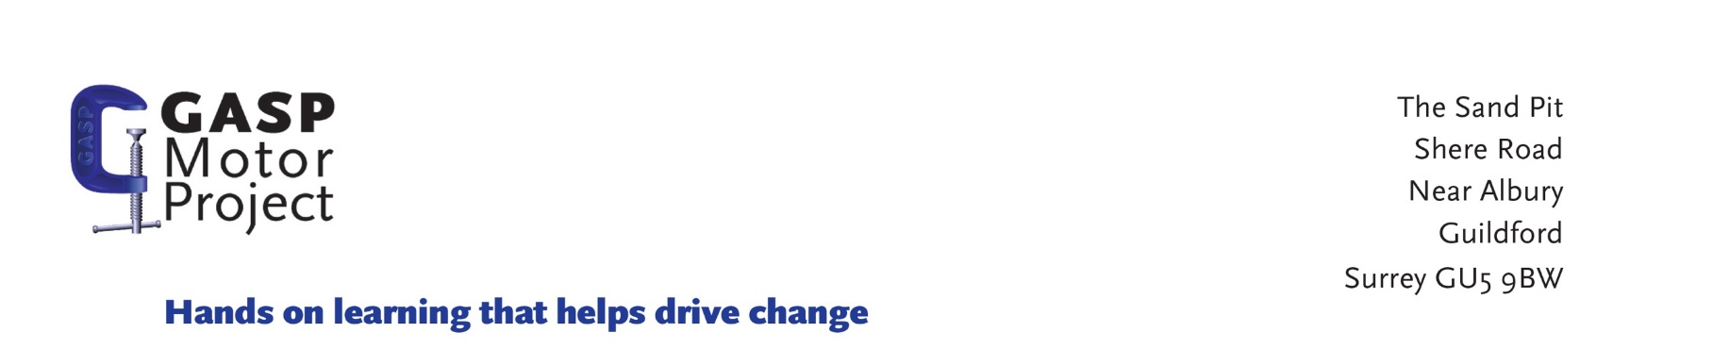

Identity verification form

All GASP paid staff and volunteers are all required to evidence their identity as part of the DBS Disclosure process.
For roles that are not eligible for DBS Disclosure, the identity of the applicant must be evidenced with the same documents accepted by the DBS.

The applicant must be able to provide:
-1 document from Group 1
-2 additional documents from either Group 1, or Group 2a or 2b
And at least one document MUST confirm the applicant’s current address.

Group 1 – Primary Identity Documents
- Passport
- Biometric Residence Permit
- Current Photo Driving Licence, Full or Provisional
- Birth Certificate, issued at time of birth
- Adoption Certificate

Group 2a – Trusted Government Documents
- Current Photo Driving Licence , Full or Provisional
- Current Driving Licence , Paper version
- Birth Certificate, issued after time of birth
- Marriage/civil partnership certificate
- HM Forces ID card
- Fire Arms Licence

Group 2b – Financial and Social History Documents
- Mortgage Statement
- Bank/Building Society Statement – including opening confirmation letter
- Credit Card Statement
- Financial Statement e.g. pension, endowment or benefit
- P45/P60 Statement
- Council Tax Statement
- Work Permit or Visa
- Letter of sponsorship from future employment provider
- Utility Bill
- Entitlement document from government
- EU National ID card
- Cards with the PASS accreditation logo
- Letter from Head Teacher/Principle

If the applicant is unable to provide the documents required, please refer to the DSL for additional options.
Applicant Name
Address (Incl. postcode)
DOB
Group 1/2A evidence
Passport
Passport Number
Issue Country
Date of Birth
Date of Issue
Driving Licence/Photocard
Driver Number
Country of issue
Date of Birth
Date of issue
Birth, marriage and civil partnership certificates, please take a copy. Copies will be destroyed once identity is verified.

Group 2B evidence
 | Issued within the last three months? | Current Address confirmed
Mortgage Statement | Yes □ No □ | Yes □ No □
Bank/Building Society Statement – including opening confirmation letter | Yes □ No □ | Yes □ No □
Credit Card Statement | Yes □ No □ | Yes □ No □
Financial Statement e.g. pension, endowment or benefit | Yes □ No □ | Yes □ No □
P45/P60 Statement | Yes □ No □ | Yes □ No □
Council Tax Statement | Yes □ No □ | Yes □ No □
Work Permit or Visa | Yes □ No □ | Yes □ No □
Utility Bill | Yes □ No □ | Yes □ No □

□ | I confirm that the evidence presented to verify my identity is correct and accurate and understand that any misrepresentation will result in the withdrawal of a job offer.
Signature of Candidate:
Print Name:
Date:

Signature of Verifier:
Print Name:
Date:

