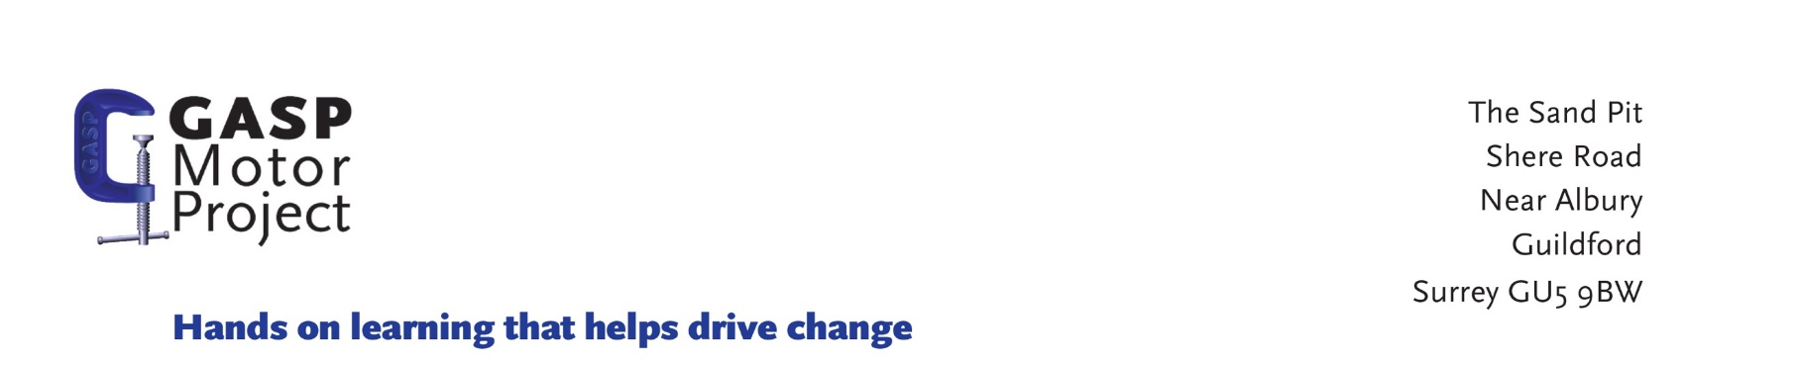

Safeguarding Self-disclosure form

For completion by the candidate applying for the role. Please bring the completed form to your interview

Name of candidate:
Previous Name (s)
Please include date(s) each name was used (MM/YYYY)
Address with Postcode

Please include dates from and to (MM/YYYY) for each address for the last 10 years
Telephone/Mobile number
Date of Birth
Gender

If the role you have applied for involves contact with children, you will also be required to undergo the relevant vetting and barring checks. Depending on the nature of the role, this could include checking criminal convictions and checking that you are not barred from working with children. All information you provide will be treated as confidential and managed in accordance with relevant data protection legislation and guidance. You have a legal right to access any information held about you.

Have you ever been know to any Children’s Services department or Police as being a risk or potential risk to Children? |  |  | Yes □ No □
If Yes, please provide further information:

Have you been the subject of any investigation by any organisation or body due to concerns about your behaviour towards children? |  |  | Yes □ No □
If Yes, please provide further information:

Have you ever been the subject of disciplinary procedures or been asked to leave employment or voluntary activity due to inappropriate behaviour towards children? |  |  | Yes □ No □
If Yes, please provide further information:

Do you have any unspent convictions? |  |  | Yes □ No □
If Yes, please provide further information:

Confirmation of declaration (tick box below)
□ | I agree that the information provided here may be processed in connection with recruitment purposes and I understand that an offer of employment may be withdrawn or disciplinary action may be taken if information is not disclosed by me and subsequently come to the organisation’s attention.
□ | In accordance with the organisation’s procedures if required I agree to provide a valid criminal record certificate and consent to the organisation clarifying any information provided on the disclosure with the agencies providing it.
□ | I agree to inform the organisation within 24 hours if I am subsequently investigated by any agency or organisation in relation to concerns about my behaviour towards children or young people.
□ | I understand that the information contained on this form, the results of the criminal record check and information supplied by third parties may be supplied by the organisation to other persons or organisations in circumstances where this is considered necessary to safeguard children.
Signature of Candidate:
Print Name:
Date:

